**1. Simple crane model (rope)**



Define the state vector, then the linear system can be rewritten into the following state-space representation:



where

;  ; .

Matlab code

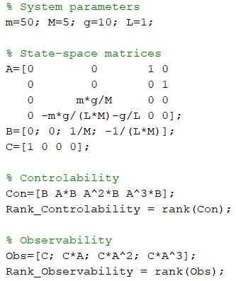

Results

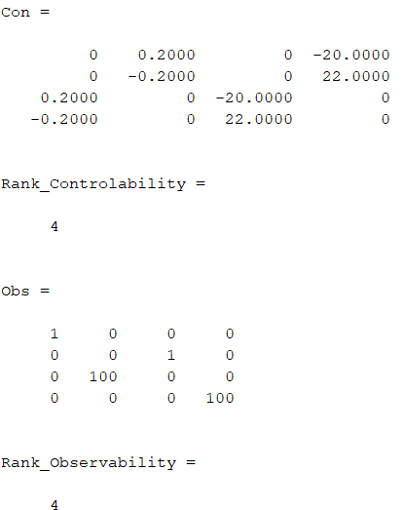

**2. Simple crane model (rod)**



Define the state vector, then the linear system can be rewritten into the following state-space representation:



where



Matlab code

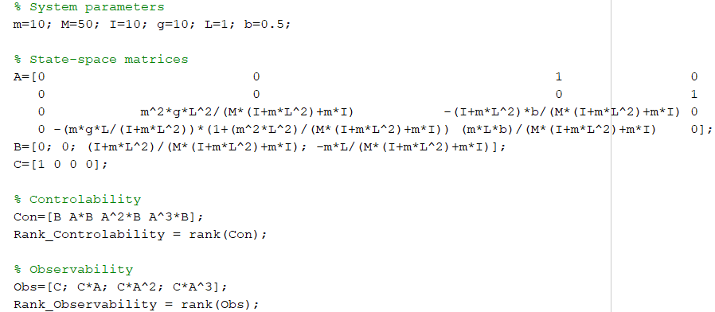

Results

